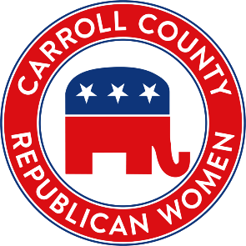
2025 Accomplishments
Engaging, Educating, and Encouraging Republican Women since 1943.
- Changed the meeting location.

- Determined a Motto: Engaging, Educating and Encouraging Women since 1943.

- Added field trips: Ronald Reagan boyhood home and Tony McCombie’s Corn Boil

- Created an inventory list of our club’s assets.

- Created timelines for each elected officer and committee, where appropriate.

- Attended the LC Home & Garden Show in June

- Helped Central Committee with the Lincoln Day Dinner in March

- Walked in 4 parades and staffed Republican booth at the County Fair

- Hosted a new member meeting in June.

- Attended 2 IFRW conferences, NFRW Biennial Convention and IFRW Biennial Convention.

- Achieved Diamond status for NFRW Club Achievement for the third time

- Donated patriotic books to three libraries.

- Awarded the Bernelle Weiler Award to a worthy recipient

- Awarded a $500 Scholarship

- Given out magnetic name tags to CCRW members.

- Set up CCRW financial books with WAVE accounting, a free accounting software program.

- Printed new membership recruitment cards

- Held a membership contest: Every 1 Bring 1

More info: www.carrollcountyrepublicanwomen.com

